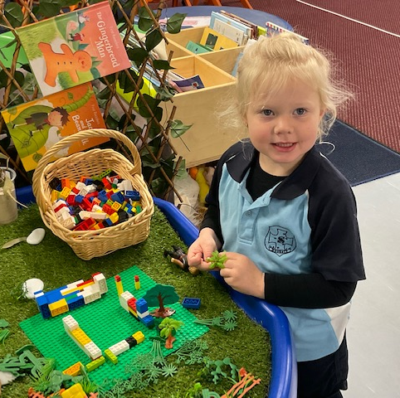
St Joseph’s Catholic Primary School

We warmly welcome you to the St Joseph’s Catholic Primary School community. We trust that your association with the school will be both happy and rewarding. The time your child will spend in primary education is a most significant period in their life and in the life of your family.
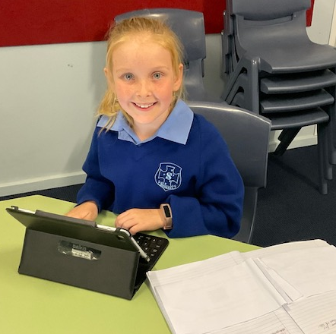
We recognise the unique contribution made by parents to the life of the school and to the learning of the children. Education today demands parents are seen as partners and active contributors in the task of enabling children to reach their full potential. When Parish, home and school share a common vision and work together there is likelihood of achieving success.

St Joseph’s School is a community of faith, with Jesus as model. Staff, students and parents work together in a spirit of Christian cooperation, with their primary goal the assistance in the spiritual, academic, physical and emotional growth of each child.
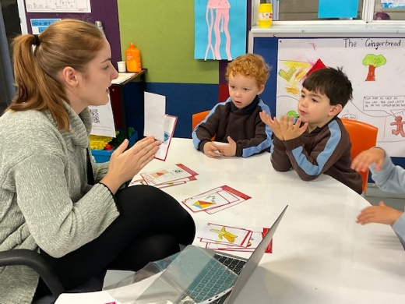
Our mission is to proclaim and witness the Gospel in a Catholic environment. We aim to integrate these values into the entire curriculum and life of the school. Our school motto ‘Honesty’ helps us to focus on what is truly important to us at St Joseph’s Catholic Primary School. Also, Saint Mary of The Cross, our Patron strived to ‘never see a need without doing something about it.’

The learning programme that is offered at our school endeavours to address the needs of all students and aims to provide the broadest range of educational experiences so that every person can enjoy achievement and success. We currently offer specialist programs in STEM (Science, Technology, Engineering, Maths), Drama, Physical Education, Chinese and Dance. Each year our Year 1-6 students attend camp and the Performing Arts (Dance). We also offer a 1:1 iPad program for students in Kindy to Year 6.

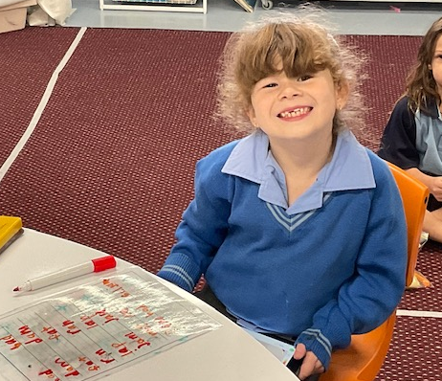
At St Joseph’s Catholic Primary School, we celebrate the relationships that exist between all members of our school community and recognise the contribution made by all groups. The staff members at St Joseph’s Catholic Primary School strive to keep abreast of educational developments and to integrate the best of the new with true educational values.
We hope you enjoy your time at St Joseph’s Catholic Primary School and we look forward to working with you to provide a quality Catholic Education for your child.

Mel Allen
Principal

